10 Tricks for Optimizing a Passivhaus
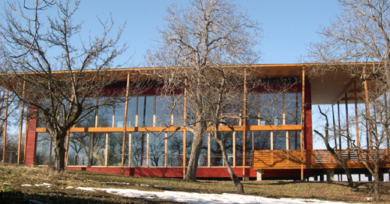
By Brute Force Collaborative
With a recent run of projects featuring over-insulated assemblies in mild climates, we’ve been pondering a way to get out the message that R-90+ assemblies just don’t make sense for most of the country, and really (if properly designed) can be avoided. Let’s say we’re designing a stunningly affordable, modern Passivhaus for you – but due to site constraints, we’re running just north of meeting the specific space heating demand (SSHD) of 4.75kBTU/ft2a. There is no need to fret – there are methods of optimizing PHPP to cross that threshold in a compliant manner. These aren’t necessarily cost effective, but as we prefer to keep things in the ‘normal’ range of things, most are. What follows is our list of potential tricks to help bump you across the PHPP space heating threshold.
1. Increase living space within the thermal envelope
Can you squeeze a loft or partial height story in the attic? Spaces w/ sloped roofs between 1-2 meters still get calculated at 50% of TFA. Do you really need a 5’ wide stair? Shrink the width of that puppy for a significant increase in TFA (and corresponding decrease in SSHD) and intimate vertical encounters. Granted, it looks awesome – but do you really need that double height space? Does the utility closet (calculated at 60%) really need to be as large as a master bathroom? Let’s design it right so things are still accessible and serviceable, while eliminating the wasted space. Finding ways to increase footage WITHIN the existing envelope can lower your SSHD.
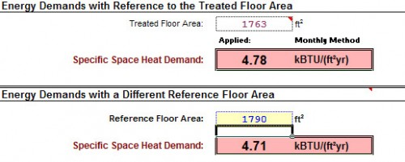
2. Keep interior column area below 0,1 m² (15.5 in²)
Keep column cross sectional areas below this threshold to prevent deduction from TFA (which will increase SSHD). Granted this may necessitate the use of steel, but that’s not always a bad thing (see: Tom Kundig). The PHPP manual states that columns with a base area below this aren’t subtracted – so if a larger wood column is needed, maybe you could get away with some sweet minimal steel cap and base action that doesn’t exceed this threshold.
3. Extend windows to finished floor
By extending windows to the floor and insetting them more than 0,13m (5.12”) from the interior finish – you can add this area to the TFA, which will reduce the specific space heating demand. It also has the added benefits of phenomenal aesthetics and allowing casements and tilt/turns to do double duty as exterior doors – usually at a lower price than an actual door. This can also increase solar gain in winter – which would further reduce specific space heating demand. Sextuple-duty bonus!
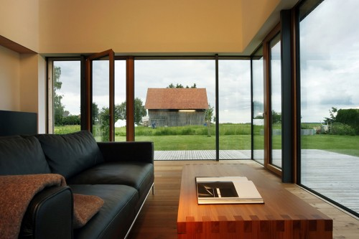
foto: djd/Deutsche Energie-Agentur
4. Better insulation for thinner exterior walls
Maybe 16” cellulose-stuffed double stud walls sounded enticing in DD, but now in CD/pre-certification polyiso or vacupor are in play. Reducing the wall thickness on a 50’x30’ house by 6” could potentially add another 75 ft² (assuming the outer extents of thermal envelope stays same). Not too shabby.
5. Similar to above, only for interior walls
Do we really need to use pocket doors and 2×6 wood walls everywhere? Not only does this add unneeded costs, but reduces the livings space within the thermal envelope (and therefore the TFA). Maybe 2-5/8” steel (or 2×4 wood) stud walls would work just as well. If you’ve got 150 linear feet of interior partitions, you could conceivably add about 36 ft² of TFA.
6. Window Psi-install
Big thanks to Bronwyn Barry, whose affinity for window porn (pdf) exceeds our own, for this tip. The ‘built-in’ psi-install for PHPP for most assemblies is 0,05 W/mK (0,029 BTU/hr.ft.F). Over-insulating window frames and positioning optimally within the wall assembly can push the psi-install closer to 0,01 W/m2K (or less given right detailing). This can have a dramatic affect on specific space heating demand. The PHPP manual states, “The standard value for Psi-installation is relatively pessimistic. Please pay attention to a thermal bridge optimized window installation and the corresponding value… Through this the heat demand can be lowered significantly.” By significant, we’re talking specific space heating demand reductions exceeding 0,4kBTU/ft²a.
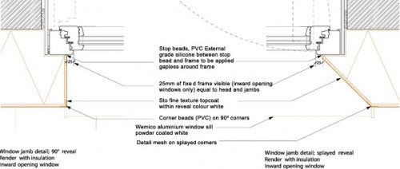

7. Ventilation Efficiency
Utilization of Certified Passivhaus components ensures the values entered into PHPP are verified and accurate. This can be crucial and have significant implications when it comes to HRV/ERV efficiency. If the product is not certified, 12% must be deducted from the heat recovery efficiency. For a (currently) uncertified product like the UltimateAir Recouperator, which claims 95% efficiency, we can only utilize 83% in PHPP. On a prefab project we’re working on, that deduction causes a 10.5% increase in SSHD, from 4.19 kBTU/ft²a to 4.63 kBTU/ft²a. This deduction may also require looking at a competing supplier, such as Zehnder, Paul, Drexel + Weiss, Luefta, etc.
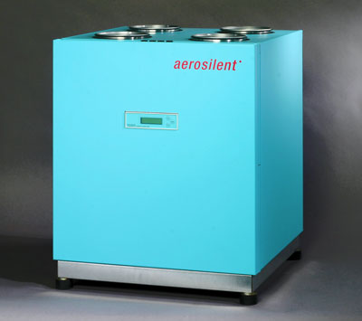
8. Change locations!
Ok, while it may be easy to move your project in PHPP from Seattle to Denver and freak out when the specific space heating demand reduces by nearly half – it’s not so easy to move your project in real life. However, it would be prudent to still verify your climate info. In Seattle, the weather station altitude is 0.00’. Houses at the top of Queen Anne Hill can be upwards of 400’. Elevation differences from the Meteornorm weather station can result in drastically differing specific space heating demands, so verify if the elevation of your house is significantly different from the weather station – if you’re lower, it may result in an improvement in your SSHD. Higher elevations could be the opposite, though.
9. Verify Shading
PHPP assumes a 25% shading factor for all windows. Entering the actual reveal depths, overhangs, etc. overrides the shading assumptions. This can improve the performance of the windows, which can potentially improve the SSHD due to increased solar gains. Be cautious, though – as the increased solar gains can also increase the percentage of overheating.
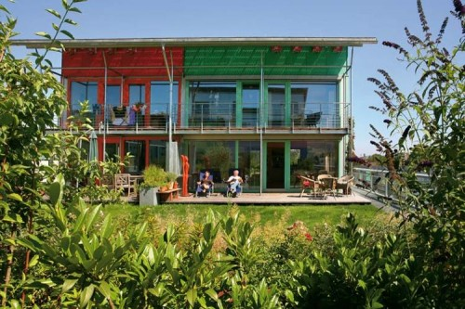
10. Thermal mass
Sure, 5/8” GWB in a Passivhaus is ‘thermal mass’ – but some of us coming from a passive solar background like a little more shake to go with our fries – and long-lasting interior finishes. Adding a little more thermal mass (such as a topping slab, or perhaps a stunning Ando-esque concrete wall with exterior insulation) can also change your numbers – however this depends significantly on design, orientation and climate. This adjustment can be significant, so it’s worth looking into. On that prefab we’re modeling, switching to a topping slab would drop the SSHD from 4.30 to 4.19kBTU/ft2a. There is no resulting increase in the space cooling demand or the frequency of overheating for this project (again, subject to design/location). This is the trick I showed some starchitects to ‘save’ a sweet Passivhaus that’s being planned for Calgary. For those that don’t remember this in training, the specific heat capacity input is at the top of the ‘Summer’ tab in PHPP.
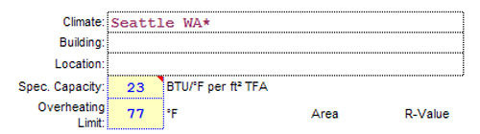

Add all these up and you could see some drastic shifts that allow you to reduce any absurd assembly values. Alternatively, it could mean getting away with less-expensive windows. Or perhaps just lowering your heating bill by another 25% per year (on top of the 90% by achieving Passivhaus) – all decent goals in our book. However, the greatest trick we can think of is to build appropriately, like multi-family housing to reduce infrastructure/embodied energy/habitat depletion.
That’s our rough and dirty guide to squeaking out a Passivhaus that just isn’t quite there. If you’ve employed these tactics – or know of any others – feel free to leave a comment. We’re big proponents of open-source knowledge and gladly share our discoveries, so please share yours.

